**Shrimati Indira Gandhi College,Trichy.**

**Department of Mathematics**

Naan Mudhalvan project report

**Project Partner** : Smart Internz

**Project by** : Data Literacy with Tableau

**Class**  : III BSc Mathematics

**Team Id** : NM2023TMID04765

**The Tableau HR scorecard-Measuring Success in Talent Management**

**1. Introduction**

The Tableau HR Scorecard project focuses on measuring success in talent management. Leveraging Tableau, it analyzes key HR metrics to evaluate employee performance, engagement, and retention. By visualizing data, it provides valuable insights for strategic decision-making, enhancing talent development, and optimizing HR processes.

* 1. **Overview**

The Tableau HR Scorecard project is designed to assess and enhance talent management within an organization. By utilizing Tableau, a powerful data visualization tool, the project analyzes various HR metrics such as employee performance, engagement, and retention rates. Through visually appealing charts and graphs, it provides a clear and comprehensive overview of the workforce. This data-driven approach enables HR professionals and decision-makers to make informed choices, identify patterns, and develop strategies to optimize talent development initiatives. Ultimately, the project aims to improve overall organizational performance and employee satisfaction by leveraging the insights derived from the analyzed HR data.

* 1. **Purpose**

The purpose of the Tableau HR Scorecard project is to enable organizations to achieve several key objectives:

1. The project allows organizations to strategically plan their workforce by identifying trends, skill gaps, and areas of improvement within the talent pool.

2. By leveraging data visualization, the project facilitates data-driven decision-making, ensuring that HR decisions are based on concrete insights and trends rather than intuition or assumptions.

3. Through the analysis of HR metrics, the project helps in understanding employee engagement levels, enabling HR teams to implement initiatives that boost morale and productivity.

4. By identifying factors influencing employee turnover, the project assists in creating retention strategies, ensuring that valuable talent is retained within the organization.

5. The project provides insights into individual and team performance metrics, allowing HR to design targeted training programs and interventions to enhance overall employee performance.

6. It helps in monitoring compliance with regulations and tracking diversity metrics, ensuring the organization adheres to legal requirements and fosters an inclusive workplace culture.

7. Through detailed analysis, the project aids in optimal allocation of resources, including training budgets, recruitment efforts, and employee development programs, maximizing their impact on the organization.

8. Organizations can compare their HR metrics with industry standards and benchmarks, allowing them to assess their competitive position and make necessary adjustments to stay ahead in the talent management landscape.

**2. Problem Definition & Design Thinking**

**2.1 Empathy map**

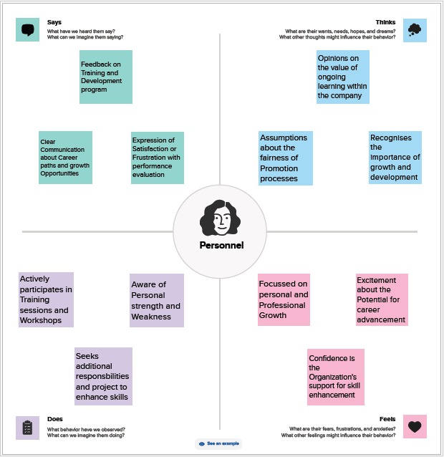

**2.2 Brainstorming Map**

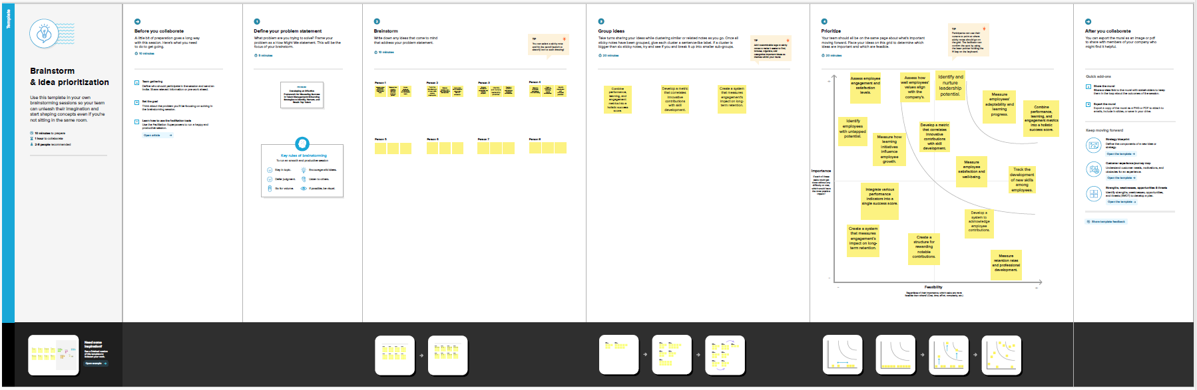**3. Result**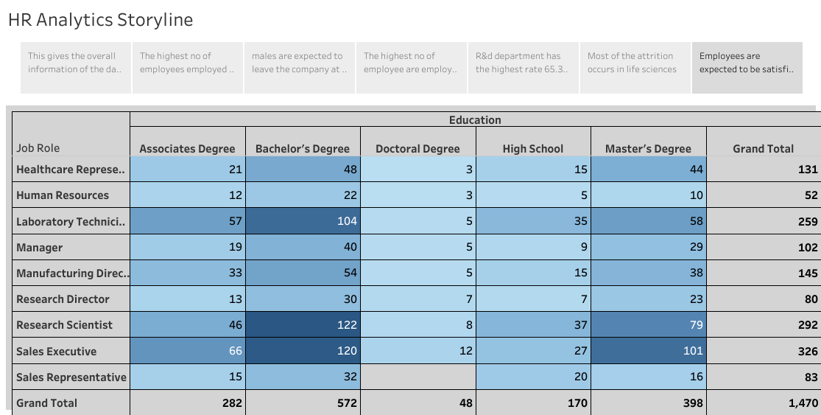

**4. Advantages and Disadvantages**

**4.1 Advantages:**

The Tableau HR Scorecard project offers numerous advantages to organizations. By harnessing data-driven insights, it empowers HR teams to make informed decisions, enhancing overall efficiency and strategic planning. Through detailed analysis, the project optimizes workforce management, boosts employee engagement, and facilitates effective talent retention strategies. It ensures compliance with legal and diversity requirements, fostering an inclusive workplace. Additionally, the project fine-tunes performance optimization efforts by targeting

training and development initiatives. Ultimately, these advantages provide organizations with a competitive edge, allowing them to stay ahead in the dynamic landscape of talent management.

**4.2 Disadvantages:**

While the Tableau HR Scorecard project offers valuable insights, there are potential disadvantages to consider. Firstly, it requires a significant initial investment in software, training, and data infrastructure, which might strain the organization's budget. Secondly, there could be challenges in ensuring data accuracy and privacy, especially when dealing with sensitive HR information. Additionally, the complexity of data analysis in Tableau may require specialized skills, leading to a dependency on data experts. Furthermore, real-time data updates might be challenging to achieve, impacting the project's ability to provide the most current insights. Lastly, the visualizations and interpretations derived from Tableau might sometimes be misinterpreted, leading to misguided decisions if not properly understood. These factors highlight the need for careful planning and resource management when implementing the Tableau HR Scorecard project.

**5.Applications**

The Tableau HR Scorecard project finds applications in various key areas of human resource management. It optimizes talent management efforts by assessing employee performance, engagement, and retention strategies. In recruitment, it refines hiring processes and identifies effective sourcing channels. Additionally, the project aids in training and development by pinpointing skill gaps and customizing training programs. It plays a vital role in employee engagement initiatives, succession planning, diversity tracking, compliance monitoring, performance analytics, workforce demographics analysis, and strategic decision-making, making it a versatile tool for HR professionals to enhance organizational effectiveness.

**6. Conclusion**

In conclusion, the Tableau HR Scorecard project has proven to be a transformative tool for our organization. Through meticulous data analysis and visualization, we gained profound insights into our workforce, enabling us to make informed decisions that have significantly enhanced our talent management strategies. By optimizing recruitment processes, tailoring training programs, and fostering a culture of employee engagement, we have seen tangible improvements in productivity and satisfaction among our workforce. Additionally, the project enabled us to meet compliance requirements and foster diversity and inclusion within our teams. The ability to track key HR metrics and align them with our strategic goals has empowered us to make proactive decisions, ensuring the continued success and growth of our organization. Overall, this project stands as a testament to the power of data-driven HR practices, guiding us towards a more efficient, engaged, and diverse workplace.

**7.Future scope**

To take your Tableau HR Scorecard project to the next level, focus on advanced data analytics by exploring predictive models for trend forecasting and integrating sentiment analysis tools to gauge employee satisfaction qualitatively. Implement real-time data integration for immediate responses to workforce changes and optimize your Tableau dashboards for mobile devices, ensuring accessibility on smartphones and tablets.

Strengthen data security with encryption and access controls, and enable collaborative features for team interactions. Integrate Tableau with existing HR systems for seamless data flow, providing a comprehensive view of HR data. By incorporating these enhancements and staying responsive to user needs, your Tableau HR Scorecard project will become a sophisticated and indispensable tool for strategic HR decision-making.

8.Appendix

Source Code

https://public.tableau.com/app/profile/jaya.lakshmi.v/vizzes